Context of Use and User Interface Requirements for Freedom Tracker
COS20001 - User-Centred Design
Due date: 23/2/2025
Team Code (from Canvas): Group 2
Names of contributing students:
- Ta Quang Tung - 104222196
- Nguyen Quang Huy - 104169507
- Do Quang Minh - 104175326
- Doan Trung Nghia - 104221559
- Pham Quang Minh - 104999568
Word count: 6354

Contribution Statements
Name | Contribution
Ta Quang Tung | Section 4 - User Requirements  Proof-reading and formatting document
Nguyen Quang Huy | Section 2 - Context of Use  Section 3 - Models - User Model
Do Quang Minh | Section 1 - Background  Section 3 - Models - Environment Model
Doan Trung Nghia | Executive Summary  Section 3 - Models - Flow /Task Model
Pham Quang Minh | Section 2 - Context of Use  Section 5 - Discussion and Conclusion

Executive Summary
Dementia is a complex condition that affects a person’s memory, communication skills, and daily activities, placing a significant burden on caregivers. Most of the time, the caregivers are family members who cannot always dedicate all of their time to take care of a person with dementia, leading to a crucial concern regarding their safety. This project aims to develop an application called Freedom Tracker that eases the burden on caregivers while also allowing people with dementia to live freely. As the first step of this project, this document presents an analysis of the system’s context of use and defines its requirements based on data from 3 interviews. The family members of people with dementia (spouses and children) have been identified as the primary user group and the task environment is modelled around them. From this analysis, 17 functional requirements and 4 usability requirements were defined which can be grouped into 4 main categories: location tracking, networking and emergency contacts, task and appointment management, and symptom logs and dementia research. The information presented in this document will be the basis for the design and prototype in the next phase.

Table of Contents
Context of Use and User Interface Requirements 1
Contribution Statements 2
Executive Summary 3
Table of Contents 4
1 Background 6
2 Context of Use 8
User Groups 8
Primary user group 8
Secondary user group 8
Tertiary user group 8
Goals 9
Environment 9
Physical Environment 9
Technological Environment 10
Artifacts 10
Social Environment 10
3 Models 12
User Models 12
Spouse of a person with dementia 12
Child of a person with dementia 13
Flow/Task Model 13
Scenario 1: Location Tracking 13
Scenario 2: Networking and Emergency contacts 14
Scenario 3: Task and appointment management 16
Scenario 4: Symptom Logs and Dementia Research 17
Environment Model 18
4 User Requirements 19
Affinity Diagram 19
Requirements 22
Location Tracking 22
Networking and Emergency Contacts 25
Task and Appointment Management 27
Symptom Logs and Dementia Research 29
5 Discussion and Conclusion 32
References 33
Appendix 34

1 Background
Dementia is a complex cognitive condition that interferes with a person’s memory, thinking, and daily activities. It includes diseases such as Alzheimer's disease and vascular dementia. As the condition progresses, a person with dementia may find it difficult to remember information, recognize people, and make decisions, posing significant challenges for caregivers and loved ones (What Is Dementia? Symptoms, Types, and Diagnosis | National Institute on Aging, n.d.). Wandering is a behavior commonly found in people with dementia, with six out of 10 people wandering at least once (Wandering | Alzheimer’s Association, n.d.). A person with dementia can become lost or get in danger when wandering, putting their caregivers in a state of worry.
Family caregivers face numerous obstacles as they balance caregiving with other responsibilities, including child-rearing, careers, and personal relationships. Numerous studies report that caring for a person with dementia is more stressful than caring for someone with a physical disability. In addition to mental health effects, dementia caregivers are also vulnerable to physical health problems, including cardiovascular issues, lower immunity, and a weaker immune response to vaccines (Brodaty & Donkin, 2009). Moreover, caregivers often lack social contact and support, leading to feelings of loneliness. Many caregivers sacrifice their hobbies, leisure activities, and time with friends and family. Some may even have to reduce their working hours or leave their jobs entirely to provide full-time care for a person with dementia (Brodaty & Donkin, 2009).
Easing the burden on caregivers and enhancing dementia care have long been a topic of interest to researchers as dementia is a condition affecting many old people. In this day and age, modern technologies present immense potential to achieve these goals. So far, several technological solutions have been developed (Lorenz et al., 2019). One solution is GPS tracking devices that allow caregivers to monitor the real-time location of a person with dementia, providing alerts if they leave designated safe areas. This technology helps manage wandering behavior and enhances safety for both the individual and the caregiver. Another technology is smart home systems that are equipped with ambient sensors such as passive infrared sensors (PIR), pressure sensors, and contact switch sensors, which monitor daily activities like walking, sleeping, or exiting the house. In the context of dementia, smart home technologies can assist individuals in performing daily activities, enabling them to live more independently and safely. Many mobile applications also exist to assist dementia caregiving such as Medisafe, which offers medication reminders, tips, drug interaction warnings, refill reminders, and progress reports. They also allow caregivers to be designated as "medfriends," receiving notifications if a dose is missed, thereby supporting medication adherence and overall health management.
The Freedom Tracker project aims to deliver a technological solution that primarily addresses the wandering behavior of people with dementia. By allowing caregivers to remotely monitor their position, they can live freely and safely without needing caregivers to always be present. In addition to tracking location, the project will also assist dementia caregivers in connecting with others, managing tasks, and researching and documenting the condition.
This document presents an analysis of the system’s context of use and user requirements as the first step of the project. Throughout this document, people who take care of those with dementia will be referred to as caregivers, while people with dementia will be called care-receivers.

2 Context of Use
Our analysis of the system’s context of use is based on the data from three interviews with caregivers. Two interviews (interviews 1 and 3) involve caregivers who are the wives of people with dementia, while the other (interview 2) involves the son of the person with dementia. Interviews 1 and 2 were obtained from Canvas, while interview 3 was obtained from YouTube (Patient experiences: living with dementia), the transcript of which is available in the Appendix.

User Groups

Primary user group
The primary user group of the system has been identified as:
- The adult family members of the person with dementia, which include their spouse and children.
The primary user group can also consist of the care-receiver’s relatives, friends, and neighbors. However, due to the lack of data, the analysis will not focus on these groups and instead treat them as secondary user groups.

Secondary user group
- Formal caregivers (nurses, etc.) and social workers
- The relatives of the care-receivers
- The friends of the care-receivers
- The neighbors of the care-receivers

Tertiary user group
- People with dementia
- Product developers

Goals
As the primary users of the system, caregivers want to keep their loved ones safe while allowing them as much independence and freedom as possible. Their main goals include:
- Ensure safety while maintaining independence: Caregivers want to allow the person with dementia to move freely within safe areas without excessive restrictions.
- Prevent wandering incidents: Caregivers are concerned about unexpected wandering and the risk of the person getting lost, especially in unfamiliar or hazardous areas.
- Receive timely alerts and location updates: Caregivers want to be notified when the person with dementia wanders into a dangerous area.
- Reduce emergency response time: In the event of wandering, caregivers want to quickly locate their loved one and coordinate assistance if needed.
- Schedule tasks and appointments: Being a dementia caregiver can greatly interfere with their schedules. Because of this, caregivers want a way to effectively plan their tasks and appointments.
- Acquire information about dementia: Caregivers that are family members of the person with dementia are unlikely to be well-informed about the condition. As such, they need a way to learn more about dementia.

Environment

Physical Environment
- Home: Many people with dementia live at home, either alone or with a spouse. While the home is a familiar and generally safe place, it still has risks like kitchen accidents or unexpected wandering.
- Out in the community: They may visit local shops, parks, or a friend’s house. While these outings are important for their well-being, they also come with the risk of them getting lost.
- High-risk areas: Busy roads, water bodies, or remote areas can be especially dangerous if they wander without supervision.

Technological Environment
- Mobile phones, landline phones, and tablets: Caregivers that are the elderly spouses of people with dementia are likely to only have a simple mobile or landline phone. They are not tech-savvy and may be resistant to new technologies. On the other hand, caregivers that are the children of people with dementia are more digitally literate and have more advanced devices like tablets and laptops.
- Internet and mobile network: It is reasonable to assume that most caregivers will have access to the Internet, regardless of their technical abilities.
- GPS and wearable devices: It can be assumed that most caregivers will have a GPS available on their mobile phones. However, it is unlikely that a caregiver will have wearable devices readily available at their homes.

Artifacts
- Sticky note reminders: A caregiver may leave reminders around the house in the form of sticky notes for the person with dementia.
- Journal entries: A caregiver may choose to document the care-receiver’s symptoms over a period of time to track the progress of their condition. They may write in paper or digital journals.

Social Environment
- Community support: Some caregivers have local shopkeepers, neighbors, friends, or social workers that can recognize their loved ones and help if needed.
- Family and friends: Some caregivers share responsibilities with other family members to care for the person with dementia. However, some caregivers live alone and do not have immediate access to family and friends.
- Healthcare providers and social organizations: Caregivers may have access to professional help from healthcare providers and social workers.
- Other caregivers: Caregivers may be able to connect with other caregivers living in the same area to share their knowledge and experience.

3 Models

User Models
The persona posters presented in this section may appear smaller when viewed in this report. Here is the link to the full-sized posters of these personas: Persona.

Spouse of a person with dementia

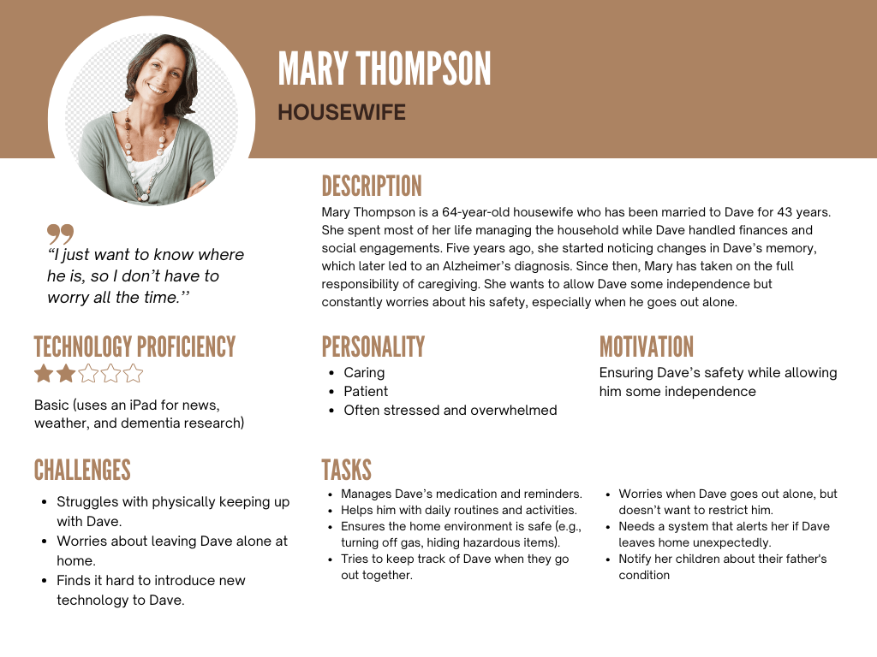
Fig. 1: Persona 1 - Spouse of a person with dementia

Child of a person with dementia

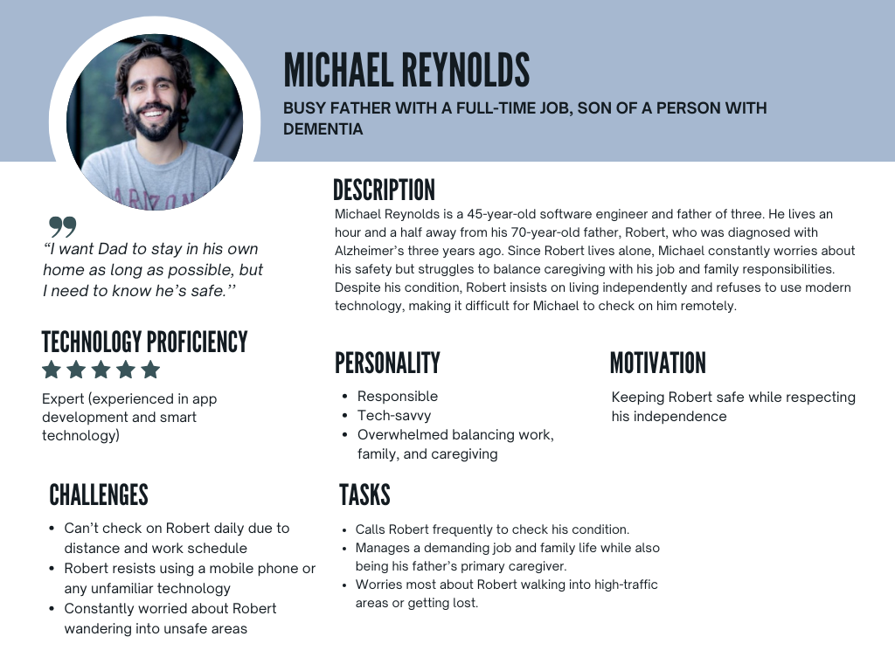Fig. 2: Persona 2 - Child of a person with dementia

Flow/Task Model

Scenario 1: Location Tracking
Mary, 64, has been caring for her husband, Dave, who has Alzheimer's. Though his memory is declining, he is still physically active and enjoys his routine of walking to the local shop. One afternoon, while she is preparing lunch, Dave decides to take his usual walk. Normally, he returns within 15 minutes, but when he doesn’t, Mary starts to worry. She calls the shopkeeper, who tells her that Dave was there earlier but has no idea where he is now. Unsure of what to do next, Mary quickly begins searching for him in their neighborhood. However, without a tracking system, she has no way of knowing which direction he went. She must ask for help from a nearby police to find him. After an hour of searching, the police finally find Dave wandering in a small park several blocks away. He looks confused and disoriented, unsure of how he got there or how to return home. Mary, relieved but emotionally drained, gently guides him back.
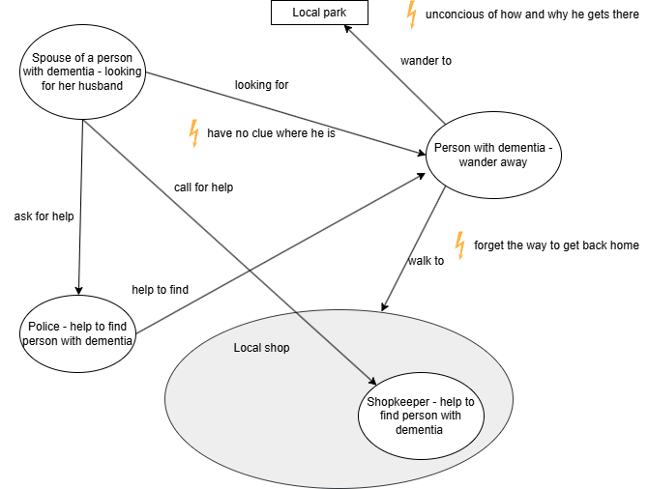
Fig. 3: Flow model for scenario 1 - User tracking (Link to full-sized diagram)

Scenario 2: Networking and Emergency contacts
Michael, 45, has been caring for his father, Robert, who has Alzheimer's. Though Robert still manages to live independently, his memory loss and occasional confusion make daily life increasingly difficult. Micheal lives over an hour away and, with a demanding job and a newborn baby, he struggles to check on his father as often as he would like. Therefore, Micheal must try to call his relatives who live nearby, but one is out of town, another is working late, and no one is available to check on his father. Unsure of what to do next, Micheal searches online and finds a nearby dementia support center. He quickly contacts them, explaining the situation and asking for advice on how to better manage his father's care from a distance. The staff provides guidance on local resources, emergency response plans, and technologies that can help track Robert’s movements. They also connect Michael with a volunteer network that can check in on George when family members are unavailable. And thanks to the help of the staff, he feels much more confident and more informed about the ways to take care of a person with dementia
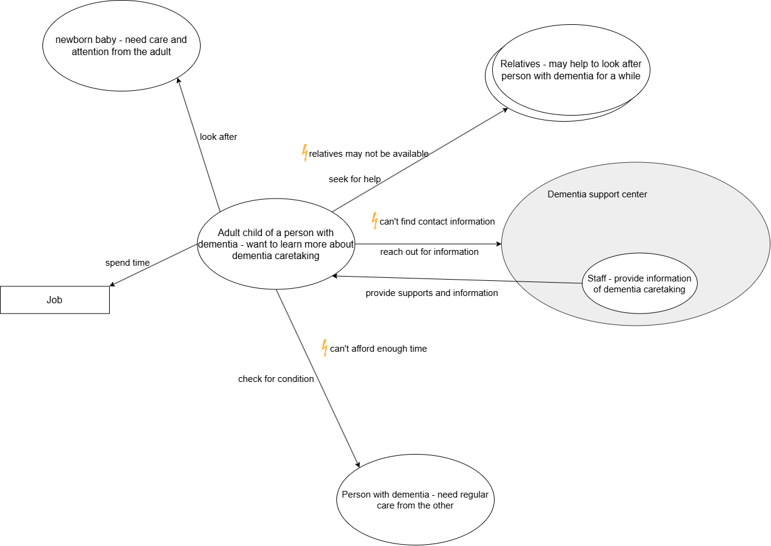
Fig. 4: Flow model for scenario 2 - Networking and emergency contacts (Link to full-sized diagram)

Scenario 3: Task and appointment management
Mary, 64, has been caring for her husband, Dave, who has Alzheimer's. Though his memory is declining, he is still physically active and wants to maintain his daily routines. However, Mary has noticed that he frequently forgets important details - whether he has taken his medication, what he was supposed to do next, or even where common household items are. To help him navigate daily life more independently, she starts writing notes and placing them around the house. Although these notes help Dave stay on track, Mary knows they are not a perfect solution. Some days he follows them easily, while on others he forgets them completely or gets frustrated by the reminders.
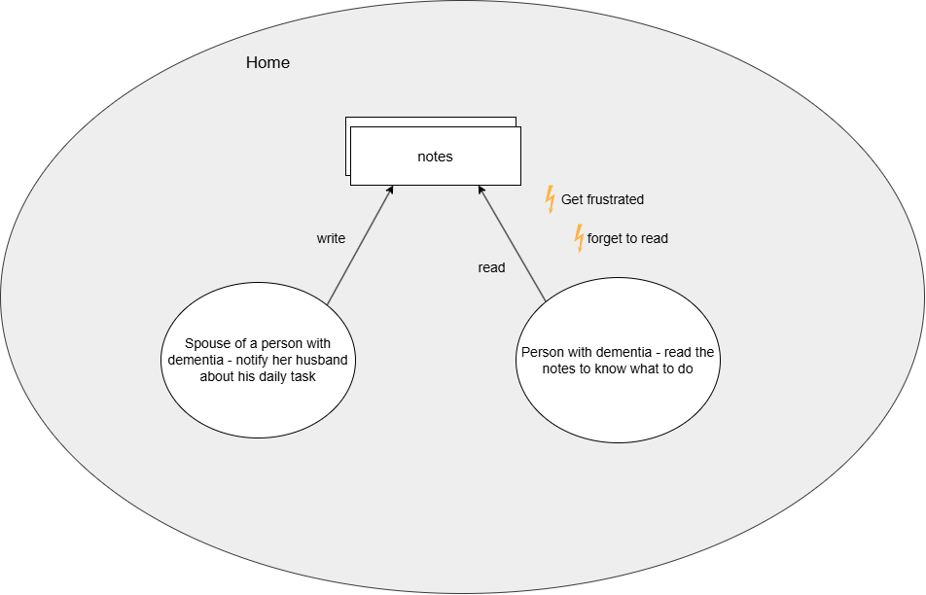
Fig. 5: Flow model for scenario 3 - Task and appointment management (Link to full-sized diagram)

Scenario 4: Symptom Logs and Dementia Research
Mary, 64, has been caring for her husband, Dave, who has Alzheimer's. That evening, after putting Dave to bed, Mary sits down with her iPad, hoping to find useful information about dementia care. She types a search query on Google and is immediately overwhelmed by countless website results - some offering practical advice, others making exaggerated claims about treatments, and many contradicting each other. Frustrated, she struggles to determine which sources are reliable. After some trial and error, she finally comes across a well-known dementia support organization’s website, which provides clear guidance and trustworthy resources. Feeling slightly more informed but aware of the challenges ahead, she decides to rely on reputable sources and look into professional advice for managing Dave’s condition.
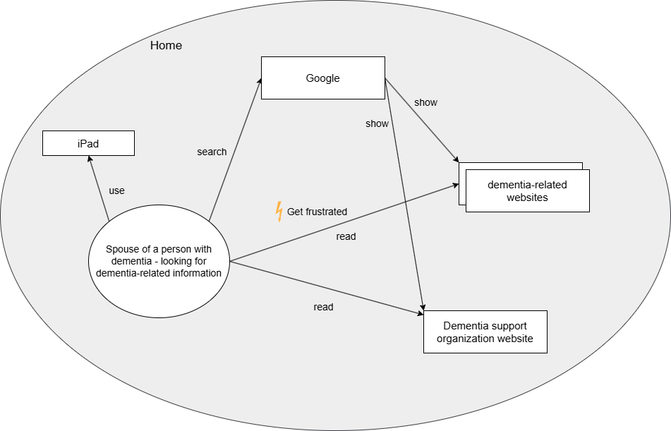
Fig. 6: Flow model for scenario 4 - Symptom logs and dementia research (Link to full-sized diagram)

Environment Model
A social model was developed to describe the environment in which dementia care takes place. It features the relationship among caregivers, care-receivers, as well as neighbors and other caregivers in the community. In addition, each group’s concern is captured in the cloud shapes.
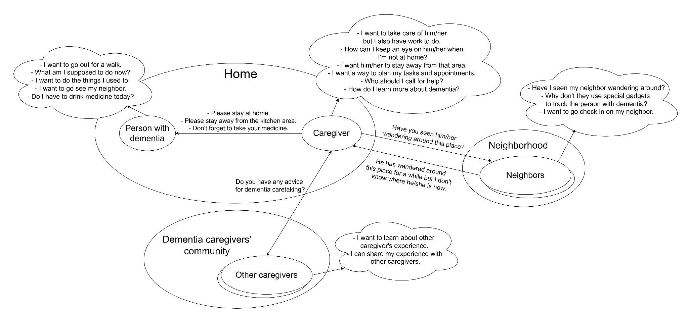
Fig. 7: Environment model (social) for the context of use (Link to full-sized diagram)

4 User Requirements

Affinity Diagram
This section presents the important details gathered from the 3 interviews, grouped into themes. Each item is given a code that will be referenced by the requirements for traceability. The user requirements presented afterwards are based on these items.
A - User concerns
This theme includes the concerns and wishes of caregivers - the primary user group.
Entry | Interview source | Ref. code
I don't want my husband to enter certain parts of the house. | 1.06 | A1
I don't take my husband to large public places because sometimes I lose him. | 1.09 | A2
I don't like leaving my husband alone at home because he will try to do something dangerous. | 1.12 | A3
I worry when I don't know where my husband is going. | 1.15 | A4
I want to know where my husband is. | 1.19 | A5
I feel at peace knowing someone is checking on my father. | 2.06 | A6
I am worried by the thought of not knowing where my father is. | 2.07 | A7
I don't want my father to go to a specific place in the neighborhood. | 2.08 | A8
I cannot let my husband walk too much because I have to watch him. | 3.01 | A9
I feel lonely because it feels like my husband is not here with me anymore. | 3.04 | A10
I would like to keep a periodic record of my husband's symptoms for future reference. | 3.05 | A11
As a carer, I want to know information about dementia. | 3.06 | A12

B - User tasks
This theme includes the tasks that caregivers are doing to take care of people with dementia.
Entry | Interview source | Ref. code
I have a mobile phone to manage appointments and update my children. | 1.04 | B1
I have an iPad to check the news and weather and research dementia care. | 1.05 | B2
I leave my husband reminders to get him started on tasks. | 1.06 | B3
I have to spend a lot of time and compromise my schedule to resolve incidents. | 2.05 | B4
I do everything for my husband, such as getting his clothes and feeding him. | 3.01 | B5

C - User attributes
This theme includes the descriptions and characteristics of caregivers.
Entry | Interview source | Ref. code
I struggled to use a mobile phone when I first got it. | 1.04 | C1
I used to rely on my children to do things on the phone. | 1.04 | C2
I am not as physically fit as I used to be. | 1.10 | C3

D - User environment
This theme includes the details of the environment in which the caregivers live and do their tasks.
Entry | Interview source | Ref. code
I live alone with my husband. | 1.04 (implied) | D1
I still take my husband out for family gatherings because we can all watch after him. | 1.09 | D2
Some people we know are aware of my husband's dementia and know to call me. | 1.14 | D3
I have kids and a full-time job. | 2.01 | D4
I don't live close to my father with dementia. | 2.01 | D5
I find information about dementia through the Alzheimer's society. | 3.03 | D6
I have a social worker whom I can call when I need help. | 3.04 | D7
I don't have any other family or friends whom I can rely on. | 3.04 | D8

E - Care-receiver attributes
This theme includes the descriptions and characteristics of care-receivers - people with dementia.
Entry | Interview source | Ref. code
My husband cannot remember things and repeat himself in a conversation. | 1.01 | E1
My husband is on dementia medication. | 1.06 | E2
My husband gets upset for not being able to do the things he used to. | 1.07 | E3
My husband sometimes unwittingly wanders away. | 1.09 | E4
My husband still goes out alone sometimes. | 1.13 | E5
My husband gets irritated if I keep him in the house. | 1.17 | E6
My husband dislikes change. | 1.20 | E7
My husband is very fussy about what he wears. | 1.22 | E8
My father lives on his own. | 2.01 | E9
My father seems to be losing weight and forgetting to shave. | 2.03 | E10
My father doesn't remember where he put his things. | 2.04 | E11
My father is resistant to change. | 2.09 | E12
My father is unwilling to use a mobile phone. | 2.09 | E13
My husband likes to walk. | 3.01 | E14
My husband wears his address and my phone number on his neck. | 3.01 | E15

Requirements
From the information gathered from the interviews, 17 functional requirements and 4 usability requirements were defined. Each functional requirement can be traced back to the data using the reference codes listed in the tables of the previous section. They can be categorized into 4 main function groups: location tracking, networking and emergency contact, task and appointment management, and symptom log and dementia research.

Location Tracking
In all 3 interviews, caregivers expressed their concerns about care-receivers getting lost or wandering to dangerous places. This makes location tracking a critical feature of the system. Location tracking needs to operate indoors and outdoors as both places can contain hazards for people with dementia. The requirements for this category are:
Location Tracking
1.1 Real-time outdoor location tracking of care-receiver
Requirement: The user shall be able to see the precise real-time location of the care-receiver when they are outside their place of abode. [A4, A5, A7, A8, A9, E4, E5, E14]
Rationale: Being able to see the location of the care-receiver when they are outside helps caregivers determine if they are about to wander into a dangerous place.
Notes: This feature requires care-receivers to carry a GPS on their bodies at all times. Deciding where to place the GPS is an important design consideration, as some care-receivers may not have a phone or are fussy about their accessories [E8, E13]

Location Tracking
1.2 Real-time indoor location tracking of care-receiver
Requirement: The user shall be able to see the precise real-time location of the care-receiver when they are inside their place of abode. [A1, A3, E9]
Rationale: Being able to see which part of the house the care-receiver is in helps caregivers determine if they are about to do something dangerous, such as turning on the gas.
Notes: As a GPS may not be able to discern the movement of a person across different parts of the house, this feature will require specialized hardware such as cameras or motion detectors to detect a person’s presence.

Location Tracking
1.3 Designating an outdoor location as dangerous
Requirement: The user shall be able to designate an outdoor location as dangerous for the care-receiver. [A8]
Rationale: This requirement works in tandem with requirement 1.1. It helps the system to automatically determine if the care-receiver is wandering into a dangerous location and warn the caregiver.

Location Tracking
1.4 Designating an indoor location as dangerous
Requirement: The user shall be able to designate a part of the care-receiver’s place of adobe as dangerous. [A1, A3]
Rationale: This requirement works in tandem with requirement 1.1. It helps the system to automatically determine if the care-receiver is wandering into a dangerous part of the house and warn the caregiver.

Location Tracking
1.5 Notifying caregivers of danger
Requirement: The user shall receive a notification when the care-receiver enters the vicinity of an indoor or outdoor location designated as dangerous, with full details of their position and proximity to the location. [A1, A3, A8]
Rationale: This requirement will warn the caregiver ahead of time if the care-receiver is about to get into harm’s way. It is especially useful if the caregiver is not present.
Notes: This feature requires users to turn on their device notifications.

Location Tracking
1.6 Efficiency of Location Tracking (usability requirement)
Requirement: The user shall be able to tell the position of the care-receiver after at most 3 seconds.
Rationale: The caregiver must be able to quickly discern the location of the care-receiver to ensure that they are not in danger.

Networking and Emergency Contacts
Taking care of a person with dementia is a draining task that can easily overwhelm caregivers, especially if they are doing it for the first time. In addition, due to work or other obligations, a caregiver cannot always be present to look after a person with dementia. As such, they will sometimes need assistance from other people, be it friends, neighbors, or social workers. As expressed by caregivers in the second and third interviews, having someone to check in on the care-receiver or to provide them with information greatly eases their worry. Thus, connecting caregivers to others is a key function of the system. The requirements for this category are:
Networking and Emergency Contacts
2.1 Adding an emergency contact
Requirement: The user shall be able to add a person, including their name, address, and phone number, to a list of emergency contacts. [A6, B4, D3, D5, D7, D8]
Rationale: Having a list of emergency contacts allows caregivers to quickly call for help in an emergency.

Networking and Emergency Contacts
2.2 Seeing the nearest emergency contacts
Requirement: The user shall be able to see the emergency contacts that are closest to the care-receiver location. [A6, B4, D3, D5, D7, D8]
Rationale: When the caregiver is away from the care-receiver, it is helpful to know the closest source of help.
Notes: This works in tandem with requirement 1.1.

Networking and Emergency Contacts
2.3 Calling an emergency contact
Requirement: The user shall be given the option to call the emergency contact closest to the care-receiver location when they wander into a location designated as dangerous. [B4, D3, D5, D7, D8]
Rationale: A caregiver is not always available to intervene when a care-receiver gets into harm’s way. The safest and quickest option is to ask the closest source of help.
Notes: This works in tandem with requirement 1.1 and 1.3.

Networking and Emergency Contacts
2.4 Connecting with nearby caregivers
Requirement: The user shall be able to see a list of other dementia caregivers in the city that are closest to them. [D8]
Rationale: Connecting with other caregivers helps them feel less lonely and overwhelmed at their job. It also helps them gather more information about dementia.
Notes: This requires other caregivers to use the system and share their locations.

Networking and Emergency Contacts
2.5 Efficiency of Emergency Contacts (usability requirement)
Requirement: The user shall be able to call an emergency contact after at most 1 second of receiving a notification.
Rationale: Time is of the essence in emergencies, and the user should be able to immediately call someone for help.
Notes: Related to requirement 2.3.

Task and Appointment Management
A caregiver has to juggle a lot of responsibilities all at once: family, work, appointments, and caring for the person with dementia. Without a task and appointment management tool, they cannot plan their days effectively and easily get overwhelmed. The caregivers in the first and second interviews insinuated a need for such a scheduling tool. As such, this will be another requirement group of the system, albeit less important than the previous two. The requirements for this category are:
Task and Appointment Management
3.1 Scheduling a task or an appointment
Requirement: The user shall be able to add a task or an appointment and its time to a to-do list. [B1, B4]

Task and Appointment Management
3.2 Viewing all upcoming tasks and appointments
Requirement: The user shall be able to view a list of upcoming tasks and appointments sorted in chronological order. [B1, B4]

Task and Appointment Management
3.3 Task and appointment notification
Requirement: The user shall be notified of an upcoming task or appointment. A task will be notified 15 minutes prior, while an appointment 1 hour prior. [B1, B4]
Notes: The user will need to enable device notifications.

Task and Appointment Management
3.4 Notifying the care-receiver of tasks and appointments
Requirement: The user shall be given the option to call the care-receiver’s phone number (mobile or landline) to notify them of an upcoming task or appointment. [B3, E10]
Rationale: A caregiver might not always be present to remind the care-receiver of daily tasks. This feature lets them do this remotely.
Notes: The caregiver will be given this option when they receive the notification from requirement 3.3. This also requires care-receivers to have a mobile phone or be near their landline phone, which is not always possible.

Task and Appointment Management
3.5 Effectiveness of Task Management (usability requirement)
Requirement: The user shall only make at most 2 errors while scheduling a task or appointment.
Rationale: Scheduling tasks and appointments is an action that is done multiple times a day. Making it hard to do so discourages the user from using this feature.

Symptom Logs and Dementia Research
A caregiver may not be well-informed when caring for a person with dementia for the first time. In the first and third interviews, both caregivers expressed a need to learn more about the condition to better tend to their care-receivers. Additionally, the caregiver in the third interview wanted a way to record the symptoms of her husband for future reference. As such, documenting symptoms and providing dementia information is a desirable function of the system. The requirements in this category are:
Symptom Logs and Dementia Research
4.1 Documenting symptoms
Requirement: The user shall be able to record the current symptoms of a person with dementia in the form of a dated journal entry. [A11]
Rationale: This feature is useful to track the progress of the care-receiver’s condition.

Symptom Logs and Dementia Research
4.2 Viewing documentation entries
Requirement: The user shall be able to see all the documentation entries they have created, sorted in either chronological or reverse chronological order. [A11]
Rationale: This feature is useful to track the progress of the care-receiver’s condition.

Symptom Logs and Dementia Research
4.3 Browsing information about dementia
Requirement: The user shall be able to view and browse a list of information about dementia. [A12, B2]
Rationale: This feature essentially provides a detailed and concise knowledge base about dementia to caregivers. They will be able to easily look for information here without having to use a search engine.
Notes: This is a minor feature. It also requires having a separate team to compile and constantly maintain the information.

Symptom Logs and Dementia Research
4.4 Searching specific information about dementia
Requirement: The user shall be able to search for specific information about dementia in the information list. [A12, B2]
Rationale: This feature essentially provides a detailed and concise knowledge base about dementia to caregivers. They will be able to easily look for information here without having to use a search engine.
Notes: This is a minor feature.

Symptom Logs and Dementia Research
4.5 Efficiency of Dementia Research (usability requirement)
Requirement: The user shall be able to find the information they are looking for after at most 10 seconds.
Rationale: A considerable portion of the primary user group are elderly people who may be slow at reading and absorbing information. Making information easily searchable reduces the cognitive load on them.
Notes: This is a minor feature.

5 Discussion and Conclusion
This report has presented an analysis of the context of use and the functional and usability requirements for the Freedom Tracker project. For the context of use, the primary user group was modelled with 2 personas as well as the task environments. The data was drawn from three interviews with dementia caregivers, the transcripts of which are provided in the Appendix. Two interviews involve participants that are the wives of people with dementia, while the other involve the son of a person with dementia. This is one of the major limitations of the data, which is a lack of representation of the primary user group, which can include close relatives, friends, or neighbors. These users have a different level of intimacy with the care-receivers, and as such, their concerns and motivations may be different from the chosen caregivers. Another limitation to the data is the lack of information related to tasks other than tracking the location of care-receivers. The interviews only gave brief allusions to other tasks such as calling for assistance, scheduling tasks and appointments, and researching dementia care. As such, the analysis had to extrapolate and fill in the gaps, compromising its accuracy. The requirements were then based on this analysis. At this stage, the usability requirements have not been clearly defined yet. This is a task that the team aims to complete in the future, after the prototype of the system is completed.

References
Brodaty, H., & Donkin, M. (2009). Family caregivers of people with dementia. Dialogues in Clinical Neuroscience, 11(2), 217–228. https://doi.org/10.31887/DCNS.2009.11.2/hbrodaty
Lorenz, K., Freddolino, P. P., Comas-Herrera, A., Knapp, M., & Damant, J. (2019). Technology-based tools and services for people with dementia and carers: Mapping technology onto the dementia care pathway. Dementia, 18(2), 725–741. https://doi.org/10.1177/1471301217691617
Wandering | Alzheimer’s Association. (n.d.). Alzheimer’s Association. Retrieved February 23, 2025, from https://www.alz.org/help-support/caregiving/stages-behaviors/wandering
What Is Dementia? Symptoms, Types, and Diagnosis | National Institute on Aging. (n.d.). Retrieved January 9, 2025, from https://www.nia.nih.gov/health/alzheimers-and-dementia/what-dementia-symptoms-types-and-diagnosis

Appendix
This section contains the transcript for Interview 3 (Patient experiences: living with dementia), formatted in the same manner as those of interviews 1 and 2. The transcripts of interviews 1 and 2 can be obtained from Canvas.
 | Transcript | Ref | Note
P3 Spouse of person with Dementia (2)

P3’s husband also participates in the interview.
I | So starting off, just tell me a bit about how long have you known each other?
P3 | Um, about 58 years, I suppose.
P3’s husband | About 58.
P3 | You've been married 57 years.
P3’s husband | Yeah, about 58 years, yeah.
P3 | There was a town hall at Stratford, I was dancing in those days and I met him at the dance, didn't I?
P3’s husband | And of course she picked on the best one because I went to this dancing school and I learned how to dance. I got bronze, silver, and gold medals so I knew that this could do all it needed to do. And that's what happened. I met her at a dance at Stratford town hall, correct?
P3 | It's correct. That's what I said. He's got short-term memory loss. We went to the doctor’s - that's how we found out. We went to the doctor’s for something or other and as Jerry walked out, he always used to say, “I'm a very good driver”. The doctor turned around and he said, “Driver?”. He said, “You don't drive, do you?” So I said, “I'm really driving for him” ‘cause I was telling him to turn left here and I didn't realize, you know. And then, he had a couple of very near scrapes. So as soon as the doctor said it was that, I said, “You'll have to give it up”, and he said, “Yeah, I know.” He must have known a bit. That was when they diagnosed that he had dementia. The first time I noticed it was the car. I've always done everything for him. He's never had to do anything really. I'd get his clothes out and so I didn't really notice that he couldn't. But after a while it got worse each year and now he doesn't do anything and he can't remember anything. Anything you tell him, he just forgets the next minute. And he still likes to walk, but we can't let him walk too much ‘cause we have to watch him. He's got a thing around his neck here that tells anybody where he lives and my phone number because he did walk off about a month ago and we had to call the police out. But he just got muddled, he just thought he was going- | 3.01
P3’s husband | I was looking for her.
P3 | No, you weren't looking for me. You went out to get two pints of milk at the bottom of the road and ended up going all the way up to Chris Street. | 3.02
P3’s husband | Really?
P3 | Yeah. That was an hour and a half we waited for you to come back.
P3’s husband | I got back then.
P3 | Oh yeah. And then you said to me, “Where have you been?”
I | How did you get in touch with Mind then? |  | Mind is a mental health organization based in the UK.
P3 | The doctor sent me there. It wasn't until we went to the Alzheimer’s society that I found out anything about it. I mean he's no trouble as long as you feed him and tell him to get in the shower and everything like that. | 3.03
I | Do you have any extra family or friends?
P3 | No, nobody. I do find it a bit much sometimes, you know. It does get on top of me a bit because you just feel lonely - you've lost your husband in a way. Though he's there, you've lost the person. You can't sit there telling him anything that's happening at that time, you know, or we're going to do this ‘cause he's forgotten it in the next minute. He's all right when we're talking about years ago, reminiscing, but it will keep going over the same ones. He’ll say, “Oh, we've been around, haven't we? We've been on lovely holidays. Oh where have we been?” And then I have to go through every holiday that we've ever taken, you know, and I say, “I've told you this about eight times.” And then you feel like you want to scream. So I rang up the Alzheimer’s society and Justina came over here. She spoke to us and all that and she give me a number and a social services number to ring. And then we started going to the Alzheimer's every month when we can. Sometimes we're on a holiday and we can't go, but otherwise we go. She's marvelous really. I know that if I needed anybody. I think that they should sort of have a review every so many months or, you know. I mean, he's got leukemia. We go every six months to the hospital and they check over and they give him blood tests and everything. They say, “He's all right. Come back in another 6 months.” Well, if you had something like that with dementia, you could tell them when he was getting worse or what was happening to him. | 3.04
P3’s husband | You’d get a reference point if you needed. | 3.05
P3 | Yeah, if they could just have him in there and again or you can ask questions. I know it's nice - it's tea and sandwiches and entertainment. But when you're a carer, you want to know information, don't you. | 3.06

